EXPERIMENT 31 – BACKWARD CHAINING

AIM
To write a Prolog program to implement backward chaining.

ALGORITHM
- Start with the required goal.
- Search for a rule that can prove the goal.
- Check the conditions of the selected rule.
- Recursively prove the required conditions.
- Display success if the goal is proved.

PROGRAM
bird(tweety).
has_wings(tweety).

can_fly(X) :-
bird(X),
has_wings(X).

is_safe(X) :-
can_fly(X).

OUTPUT

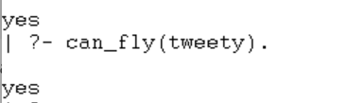

RESULT
Thus, backward chaining was successfully implemented using Prolog.

